Activity 5.6 Physical Property Analysis

Introduction
What do you need to know about a product before it is built? Would you need to know its volume, surface area, or weight? Would the product weigh less if it were made of aluminum or mild steel? What about copper, brass, or cast iron? How could this information impact the product design?

How can you find the properties of a product before it is built? You can calculate them mathematically, providing you have the material specifications, but it will take time. In today’s busy, fast-paced world, engineers use solid modeling software programs to speed up the calculating process. However, the user of the software must understand what the software is doing in order to estimate the answers and to be able to recognize a possible error.

Procedure
In this activity you will calculate the volume of a part and the surface area; you will look up the density of the material and then calculate the mass. Next, you will check your work using a 3D solid modeling software program. After you have learned how to calculate the physical properties of the example parts provided, you will then do an analysis on a puzzle cube piece and parts of your Automoblox vehicle or other consumer product.

Aluminum Object Example 1

The aluminum example is provided as an isometric drawing that will need to be created as a solid model. The grid spacing for the object shown is 0.25 inch. Using the grid, determine the measurements for each facet of the part. Recreate the isometric sketch and record each facet’s dimensions in your engineering notebook. Then calculate the volume and surface area of the object. Show your work in your engineering notebook. Next, create a model of the object with the required geometry using the 3D solid modeling software. You will assign aluminum as the object’s material and perform a physical property analysis to determine the answers to the questions. Print a copy of the CAD Physical property values and insert into your engineering notebook. When you have completed the physical property analysis, answer the questions below.
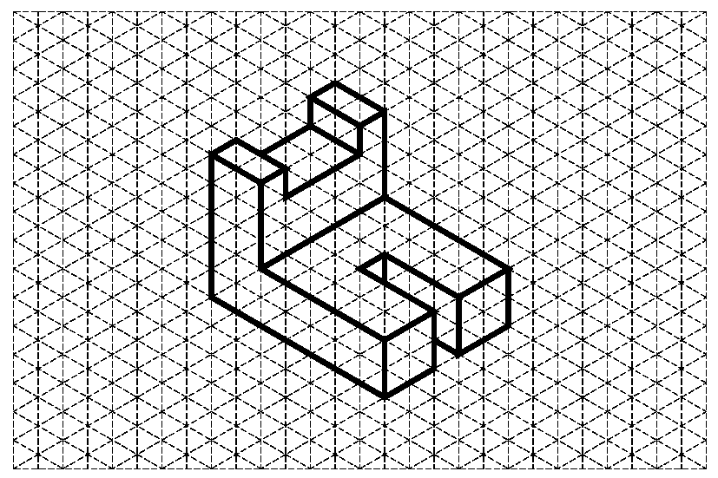
Figure 1: Isometric drawing of Aluminum Object One with 0.25” grid

Questions for Aluminum Object One

Directions: Complete the calculation by hand. Show all work below and select the appropriate answer based on your calculations. Check your work using the 3D modeling software. If your answers differ, explain why you think they are different where appropriate.

- What is the volume of the part?

- 1.875 in.³
- 1.125 in.³
- 1.375 in.³
- 2.125 in.³

SHOW WORK:

- What is the density of aluminum in grams per cubic centimeter? (This may require research. Be sure to document your source.)

- What is the density of aluminum in pounds per cubic inch? Show your work including all conversion factors.

- Find the mass of the object (in pounds-mass) if it is made of aluminum.
- 0.125 lb_{m}
- 0.135 lb_{m}
- 0.257 lb_{m}
- 0.312 lb_{m}

SHOW WORK:

- What is the surface area of the part?
- 7.250 in.²
- 8.250 in.²
- 9.250 in.²
- 10.250 in.²

SHOW WORK:

- What are the physical properties presented in the CAD software? Include units.

A. Density _______________
B. Mass _______________
C. Surface Area _______________
D. Volume _______________

If physical properties are different from hand calculated values, explain why you think they differ.

- If one quart of cleaning solution will clean 14400 in.², how many quarts will be required to clean 3000 parts? Use 3D software physical properties.

- 2.000
- 1.500
- 2.135
- 2.145

SHOW WORK:

Brass Object Example 2

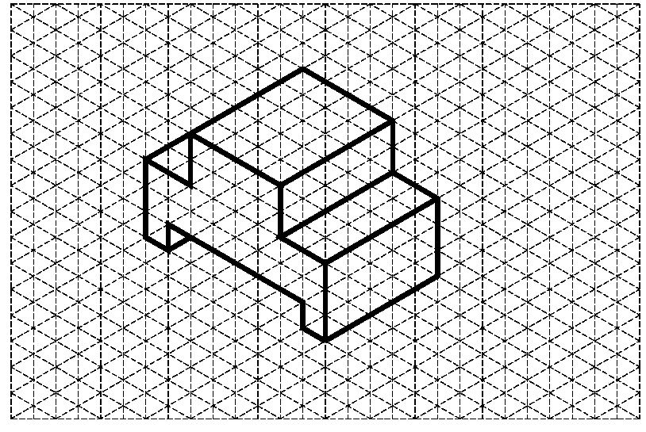
Figure 2: Isometric drawing of Brass Object One with 0.25” grid

Questions for Brass Object One

Directions: Complete the calculation by hand. Show all work below and select the appropriate answer based on your calculations. Check your work using the 3D modeling software. If your answers differ, explain why you think they are different where appropriate.

- What is the volume of the part?

- 2.375 in.³
- 3.125 in.³
- 2.031 in.³
- 4.125 in.³

SHOW WORK:

- What is the density of brass in grams per cubic inch?

- What is the density of brass in pounds per cubic inch? Show your work including all conversion factors.

- Find the mass of the object if it is made of brass.

- 0.621 lb_{m}
- 0.547 lb_{m}
- 0.257 lb_{m}
- 0.312 lb_{m}

SHOW WORK:

- What is the surface area of the part?

- 6.000 in.²
- 8.000 in.²
- 0.250 in.²
- 12.000 in.²

SHOW WORK:

- What are the physical properties presented in the CAD software? Include units.
  - Density _______________
  - Mass ___________________
  - Surface Area ___________________
d. Volume ___________________

If physical properties are different from hand-calculated values, explain why you think they differ.

- What will be the total cost to ship 100 brass parts if the shipping rate is $4.25 per pound? Use the physical properties from the CAD analysis. SHOW WORK.

Conclusion
- What do you need to know in order to perform a physical property analysis?

- Why is it important to understand the mathematics used in physical property analysis?

- Why is it important to perform a physical property analysis prior to producing a part?

- The clear enclosure piece and the wheels of the Automoblox are manufactured from polycarbonate. Do you think that the connector pieces are also manufactured from polycarbonate? Justify your answer.

